Stay Booked:
Book 90% of your leads by creating a
Sales Strategy

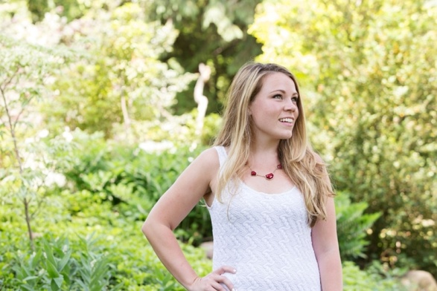
Dear person full of so much potential,
Hi. I’m Shannon and I used to be that girl that was DYYYINNGG to quit her day job. I started an Etsy shop, grew that shop into a floral design business. I was doing weddings on the weekends and had no real plan on how to actually grow my business or quit my day job.
My sales “strategy” was non-existent. I would get an inquiry and had 5 different ways to go about booking them. Each time it was like “Will this work?” Instead of actually analyzing why people booked I would just try a million different things and then wonder why no one was booking.
My 2nd year in business, I said f* this, I’m going to give it my all. I’m going to create a strategy and STICK WITH IT. I created a simplified strategy that had clients saying “Take my money!”
GUYS, IT WORKED. I booked a $10k client, I was on my way to doubling my revenue, I was getting PAID to do styled shoots, and this was my 2nd year in business.
Now I love creating strategies, teaching them, and telling people to commit to them at Shannon DePalma Coaching. LET’S DO THIS.
Step 1: Lead Phase
1.) Wooo hoooo you got a lead! Alright let’s nail this baby down.
Create the trust factor right away.
Don’t think about the sale; think about making this person feel comfortable, like a friend.
Most brides come to us with their guard up because they’re scared everyone is trying to dupe them.
Most of us are never trying to dupe our clients we want to give them the best, which is why we want their wedding.

Side note: REALLY believe you’re the best, you already know that you would over deliver for your clients. Stay confident in yourself and your services.
Start the conversation by getting on the phone, a skype meeting, or in person meeting. More trust is established in a face to face interaction.
When you talk to them, MAKE IT ABOUT THEM, not about you.
When you first talk to them make it casual, point out something you have in common Ask them: How they want their wedding to feel? What is important to them about the event? Ask them what they value as a couple or what’s important to them?
Your delivery: DON’T ACT LIKE SOME CORPORATE DBAG. BE YOU.
People more than ever love authenticity; they want to do business with a person not a person who uses words that go over their head.
Step 2: Negotiate Phase
2.) Send out a proposal that reflects your client.
Show you UNDERSTAND your vision.
Most importantly, give her options, if it’s possible.
> Always send off a proposal with a timeline, give it a week or two, depending upon the length of the proposal. <
Most of all, don’t negotiate on your prices.
If you undercharge your services, guess who wins?!
Nobody. Not even the bride because she’ll have a resentful vendor.
But Shannon I don’t act unprofessional?
< Believe me there was always a difference between my designs that were happy and those that weren’t “I didn’t charge enough!” >

Step 3: Seal the Deal
Follow up and follow up, and keep following up until they give you answer.
BE RELENTLESS because you know you are the right person for this job.

If they have questions, get them on the phone, and follow up the day when the proposal expires (1 week – 2 weeks).
Don’t be afraid to put yourself out there, be vulnerable, ask for the job.
Nobody gets sales sitting behind a computer and not putting themselves out there.
JUST DO IT.

But Shannon I need more leads?
Yes right!? Guess what!
I can help you with that too.
This involves creating a marketing calendar, that’s where we create an actual social media, blogging, and in person networking strategy.
Before you freak out at all those words, it’s actually not as scary as it seems.
It’s just a matter of breaking down big goals to small steps and committing to it.

Let me show you how to do that. I’ll show you what I did to get consistent leads and not just wait for them to MAGICALLY show up.
Watch the live class here.

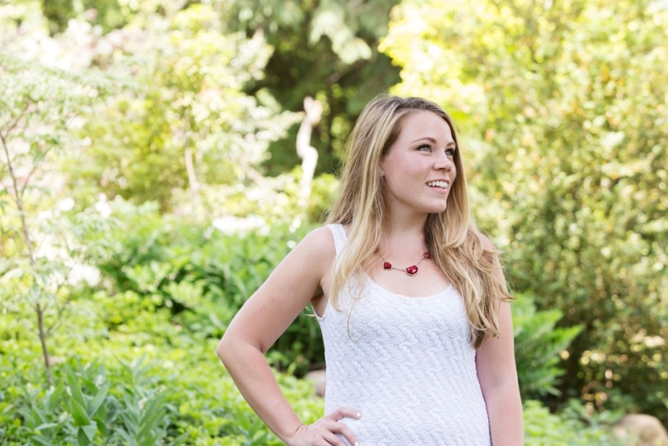
I'm Shannon and I'm a female entrepreneur.
I grew and sold a floral design business in 2 years.
Now I'm on a mission to help creative women get more sales and find their brand.
I love: business, cats, my handsome husband, and traveling.

I’d love to help you grow with more focus, more direction, and a real PLAN.
The Sales Boot Camp for Creative Women Opens April 26th with only 20 seats.
Save my seat.

